Byron Laferriere
Professor Gupta
DAD-220
31 May 2020

DAD 220 Module Four Major Activity Database Documentation Template

Follow steps 1 through 4 from the Module Three Major Activity only to generate tables for this assignment.

- Import the data from each file into tables.

There was only one command needed for all three tables to have their appropriate .CSV files attached. However, I had foreign keys attached to two of the tables, which required a slight side-step to complete. For the first upload, I started with the table Customer, which has no foreign keys and is essentially the start of the ERD. The following command was used:

LOAD DATA INFILE '/home/codio/workspace/customers.csv' INTO table Customer
-> FIELDS TERMINATED BY ','
-> ENCLOSED BY '"'
-> LINES TERMINATED BY '\n'
-> IGNORE 1 ROWS;

After completing this first step, it is necessary to change our foreign key checks that MySQL is running. To complete this step, this command was used:

SET FOREIGN_KEY_CHECKS = 0;

This command allowed the machine to bypass Foreign Key checks and add all needed information to the other two tables. After this was completed, I set the key checks back to 1.

- Write basic queries against imported tables to organize and analyze targeted data. For each query, include a screenshot of the query and its output. You should also include a brief, 1-3 sentence description of the output.
  - Write an SQL query that returns the count of orders for customers located only in the city of Framingham, Massachusetts
    - How many records were returned?
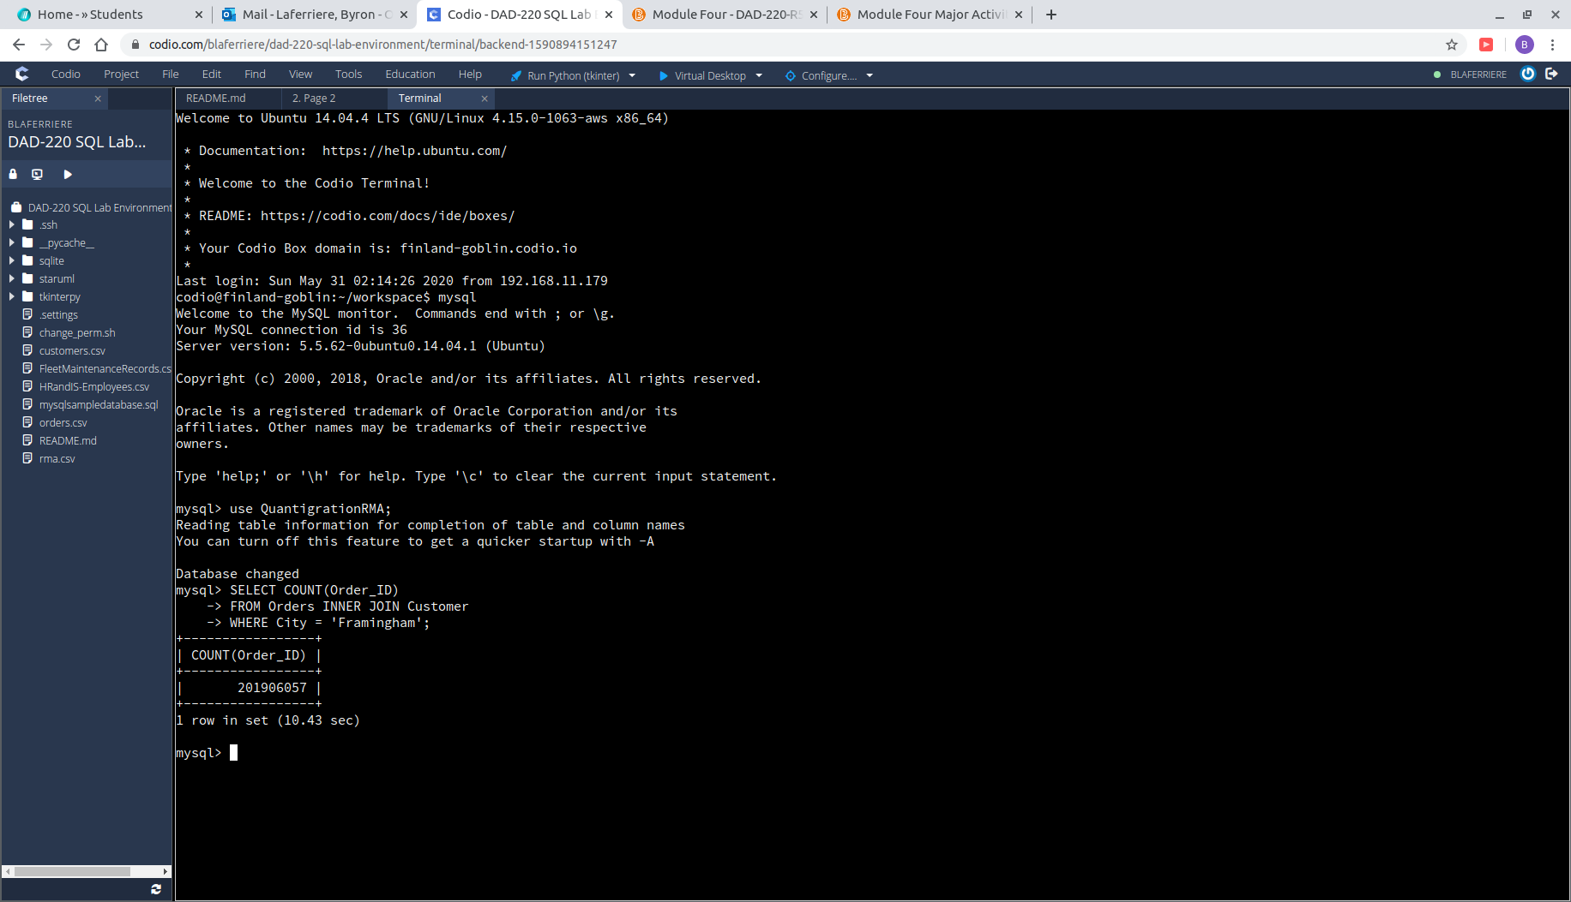

This search actually took me a while to complete. MySQL machine kept crashing from attempting to combine the two tables. I finally tried doing a COUNT() statement to just generate the final number and the result was 201,906,057.

  - Write an SQL query to select all of the customers located in the state of Massachusetts.
    - Use a WHERE clause to limit the number of records in the customers table to only those that are located in Massachusetts.
    - Record an answer to the following question: How many records were returned?

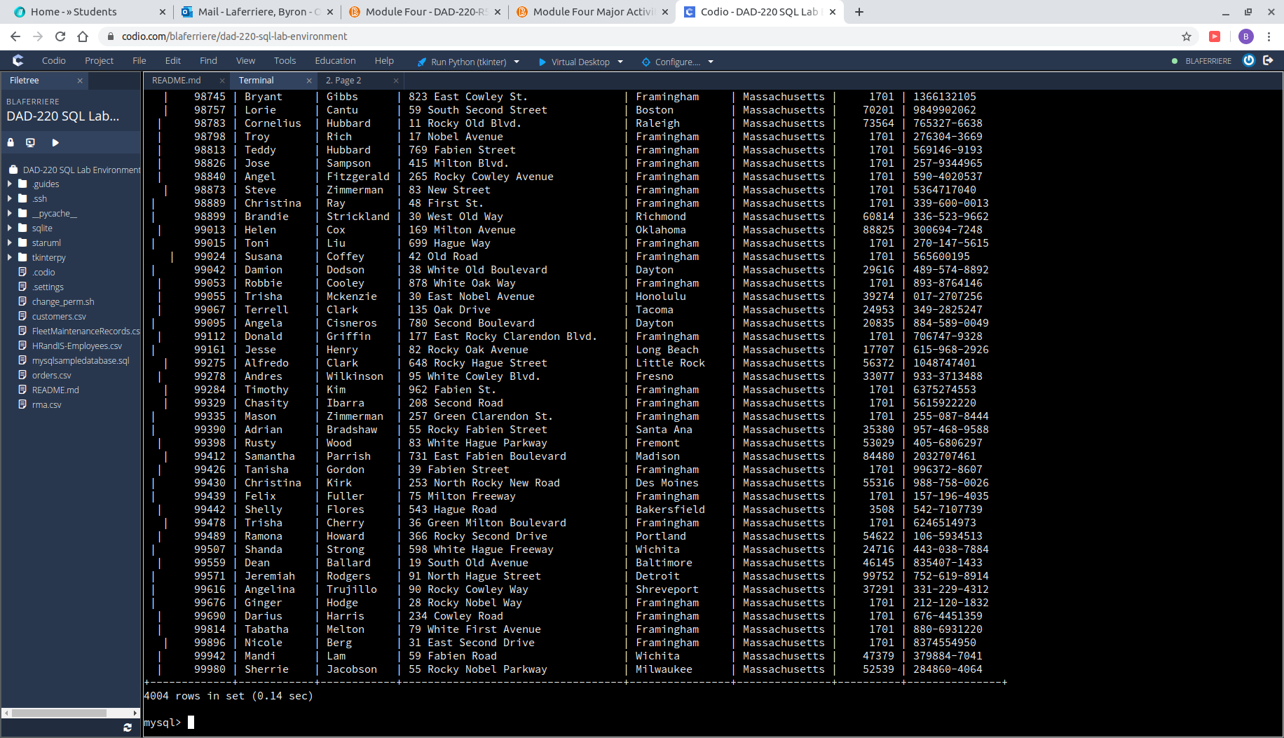
There were 4,004 records returned when searching for customers who live in Massachusetts. Using WHERE State = ‘Massachusetts’ allows the program to only display those who live in the state requested.

  - Write an SQL query to insert four new records into the orders and customers tables using the following data:

    - Customers Table

CustomerID | FirstName | Lastname | StreetAddress | City | State | ZipCode | Telephone
100004 | Luke | Skywalker | 17 Maiden Lane | New York | NY | 10222 | 212-555-1234
100005 | Winston | Smith | 128 Sycamore Street | Greensboro | NC | 27401 | 919-555-6623
100006 | MaryAnne | Jenkins | 2 Coconut Waay | Jupiter | FL | 33458 | 321-555-8907
100007 | Janet | Williams | 58 Redondo Beach Blvd | Torrence | CA | 90501 | 310-555-5678
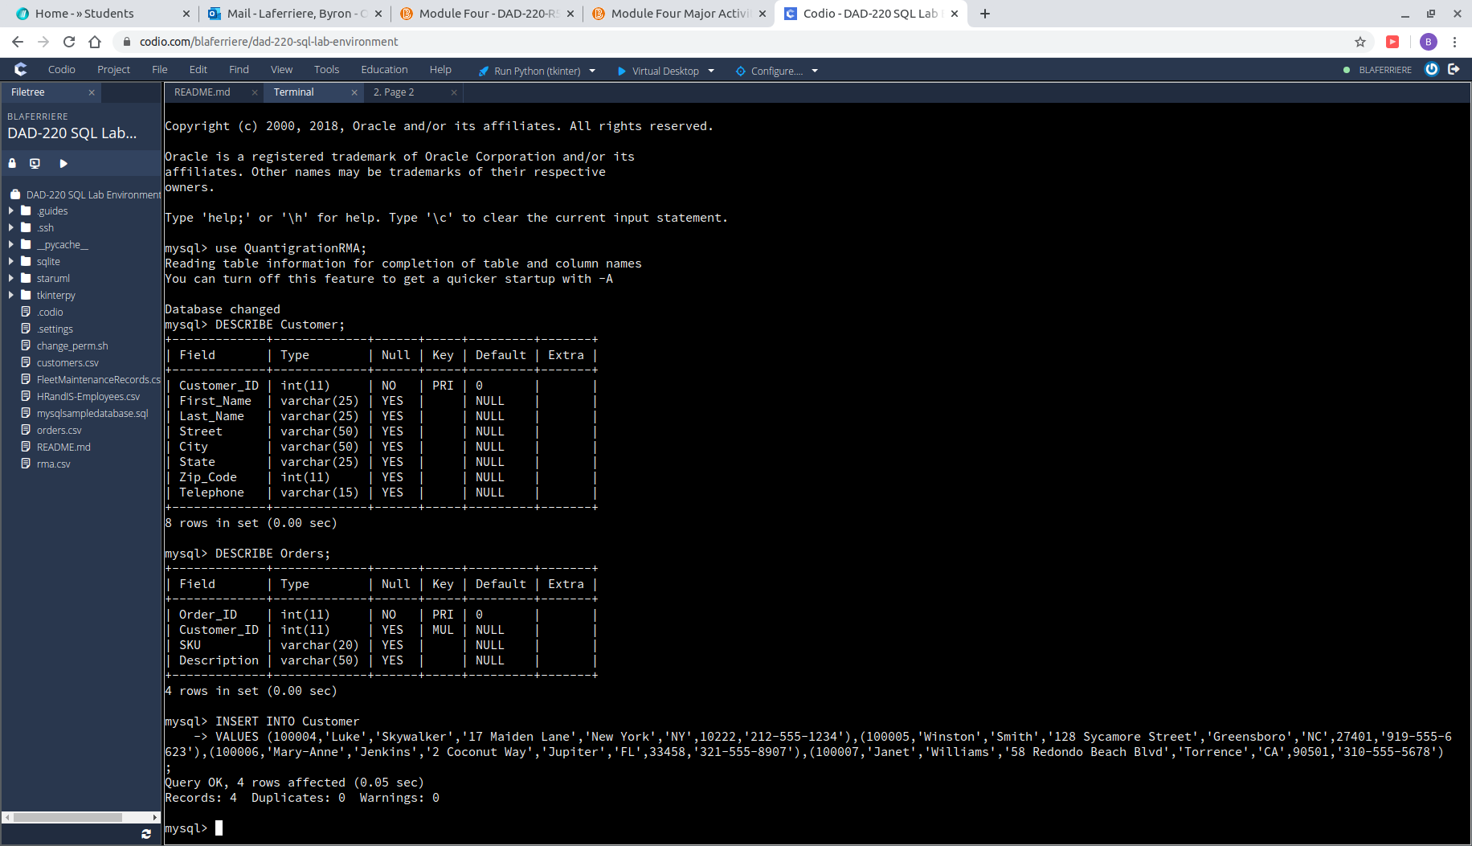
[Insert screenshot and brief explanation here.]

    - Orders Table
OrderID | CustomerID | SKU | Description
1204305 | 100004 | ADV-24-10C | Advanced Switch 10GigE Copper 24 port
1204306 | 100005 | ADV-48-10F | Advanced Switch 10 GigE Copper/Fiber 44 port copper 4 port fiber
1204307 | 100006 | ENT-24-10F | Enterprise Switch 10GigE SFP+ 24 Port
1204308 | 100007 | ENT-48-10F | Enterprise Switch 10GigE SFP+ 48 port
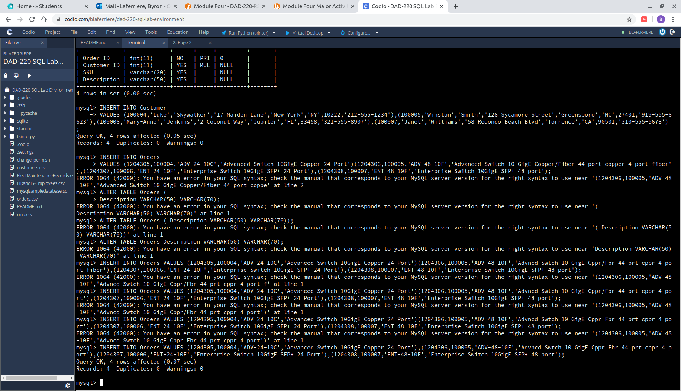
This was a tough INSERT INTO command for me to use here,Ii took me a couple times to finally realize what my mistake was. At first I thought that my description in order number 1204306 was too long for VARCHAR(50), so i started changing the VARCHAR to a higher character count. I then realized my mistake and added my missing comma to the command between value parenthesis, which allowed the INSERT INTO command to finally work.

  - In the customers table, perform a query to count all records where the city is Woonsocket, Rhode Island.
    - How many records are in the customers table where the field “city” equals ‘Woonsocket’?
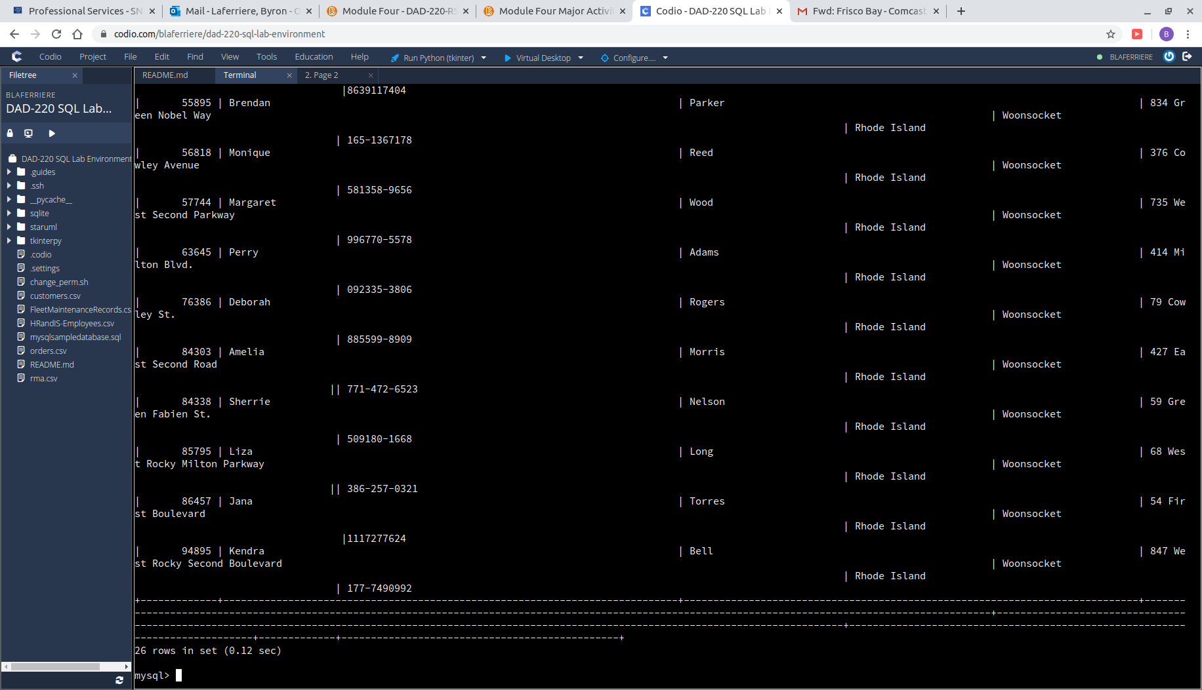
When running the WHERE City = ‘Woonsocket’ command we saw 26 rows of Customers living in that city inside Rhode Island.
  - In the rma database, update a customer’s records.
    - Write an SQL statement to select the current fields of status and step for the record in the rma table with an orderid value of ‘5175’.
      - What are the current status and step?
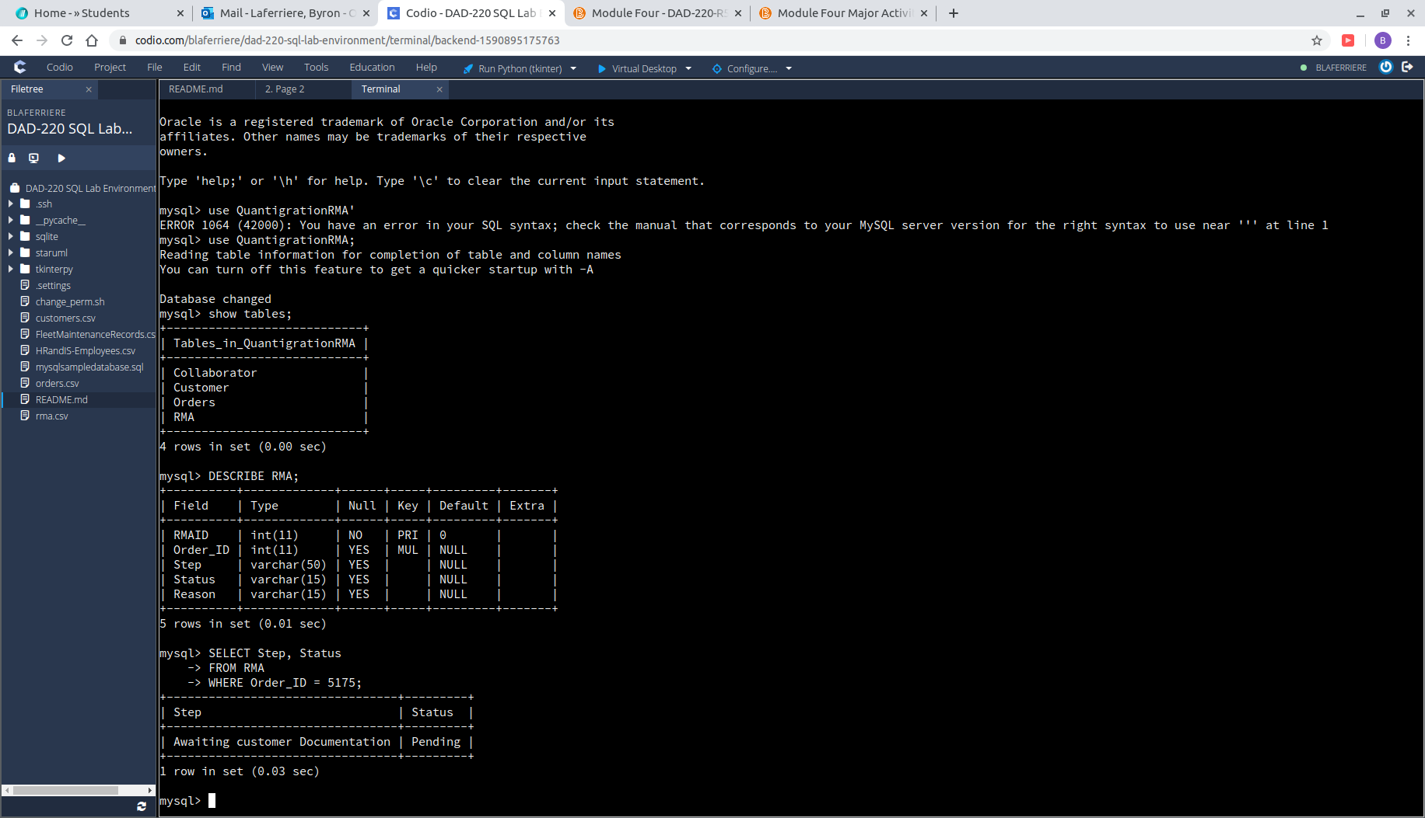
This was a simple SELECT statement that listed the desired columns after SELECT. By doing this you tell the program what columns you’d like displayed instead of the default which is all columns. We see here that the step is ‘waiting on customer documentation’ and status is ‘pending’.

    - Write an SQL statement to update the status and step for the orderid, 5175 to status = ‘Complete’ and step = ‘Credit Customer Account’
      - What are the updated status and step values for this record? - Provide a screenshot of your work.
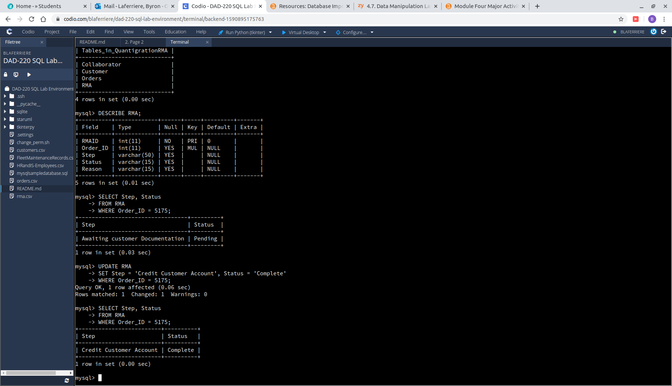
After completing the UPDATE command on the RMA table, the new status of Order_ID 5175 is now ‘Credit Customer Account’ and ‘Complete’.

  - Delete rma records.
    - Write an SQL statement to delete all records with a reason of ‘Rejected’.
      - How many records were deleted? Provide a screenshot of your work.
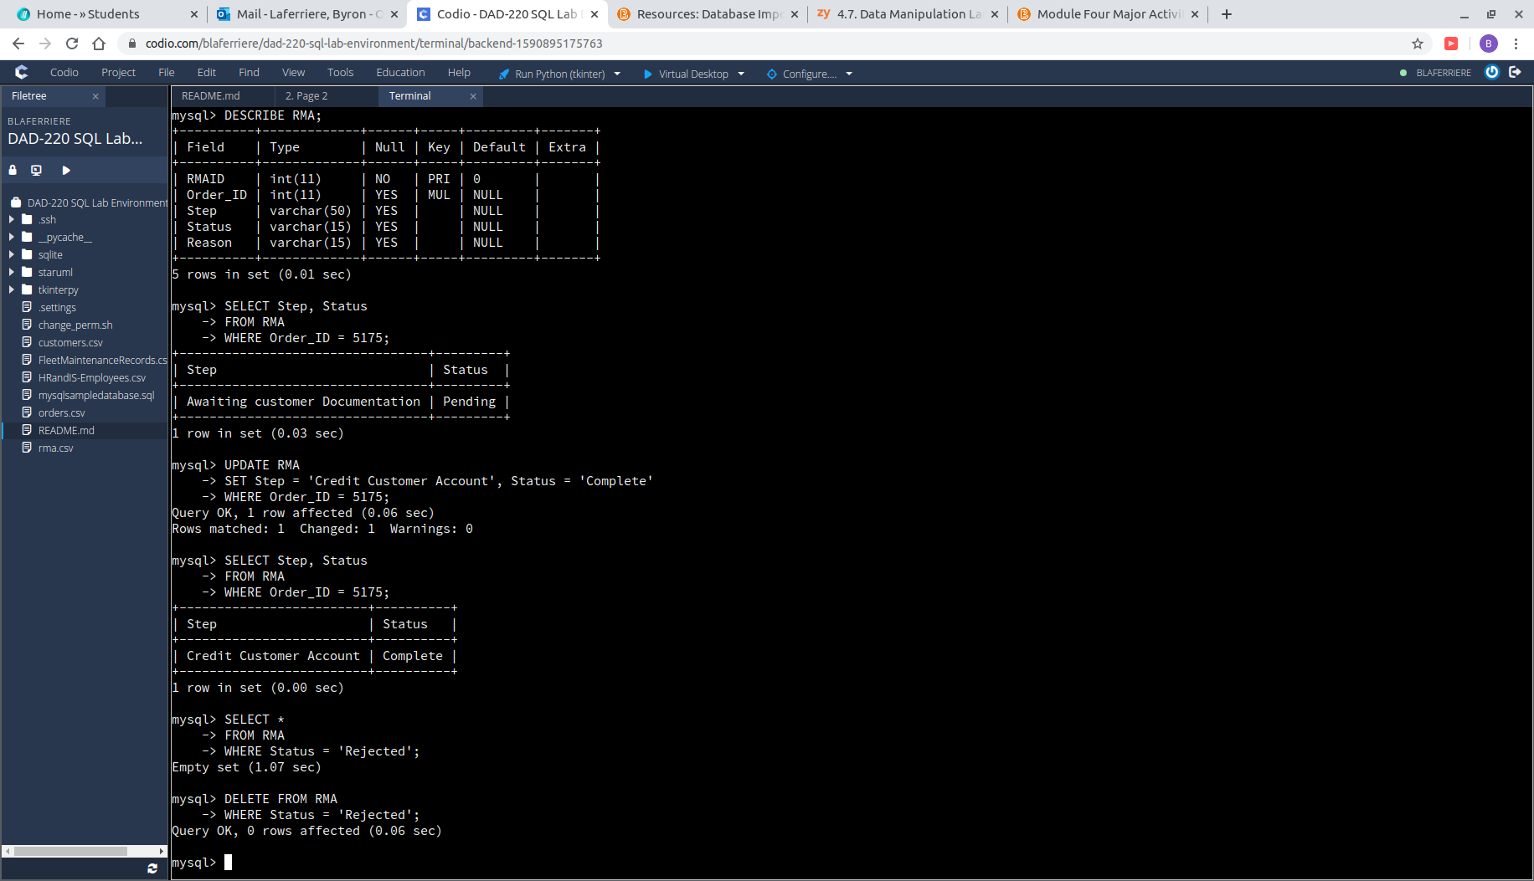
When using the DELETE FROM command in RMA to remove any applications that had been rejected, nothing returned because there were no files under that status.

- Create an output file of the required query results. Write an SQL statement to list the contents of the orders table and send the output to a file that has a .csv extension.

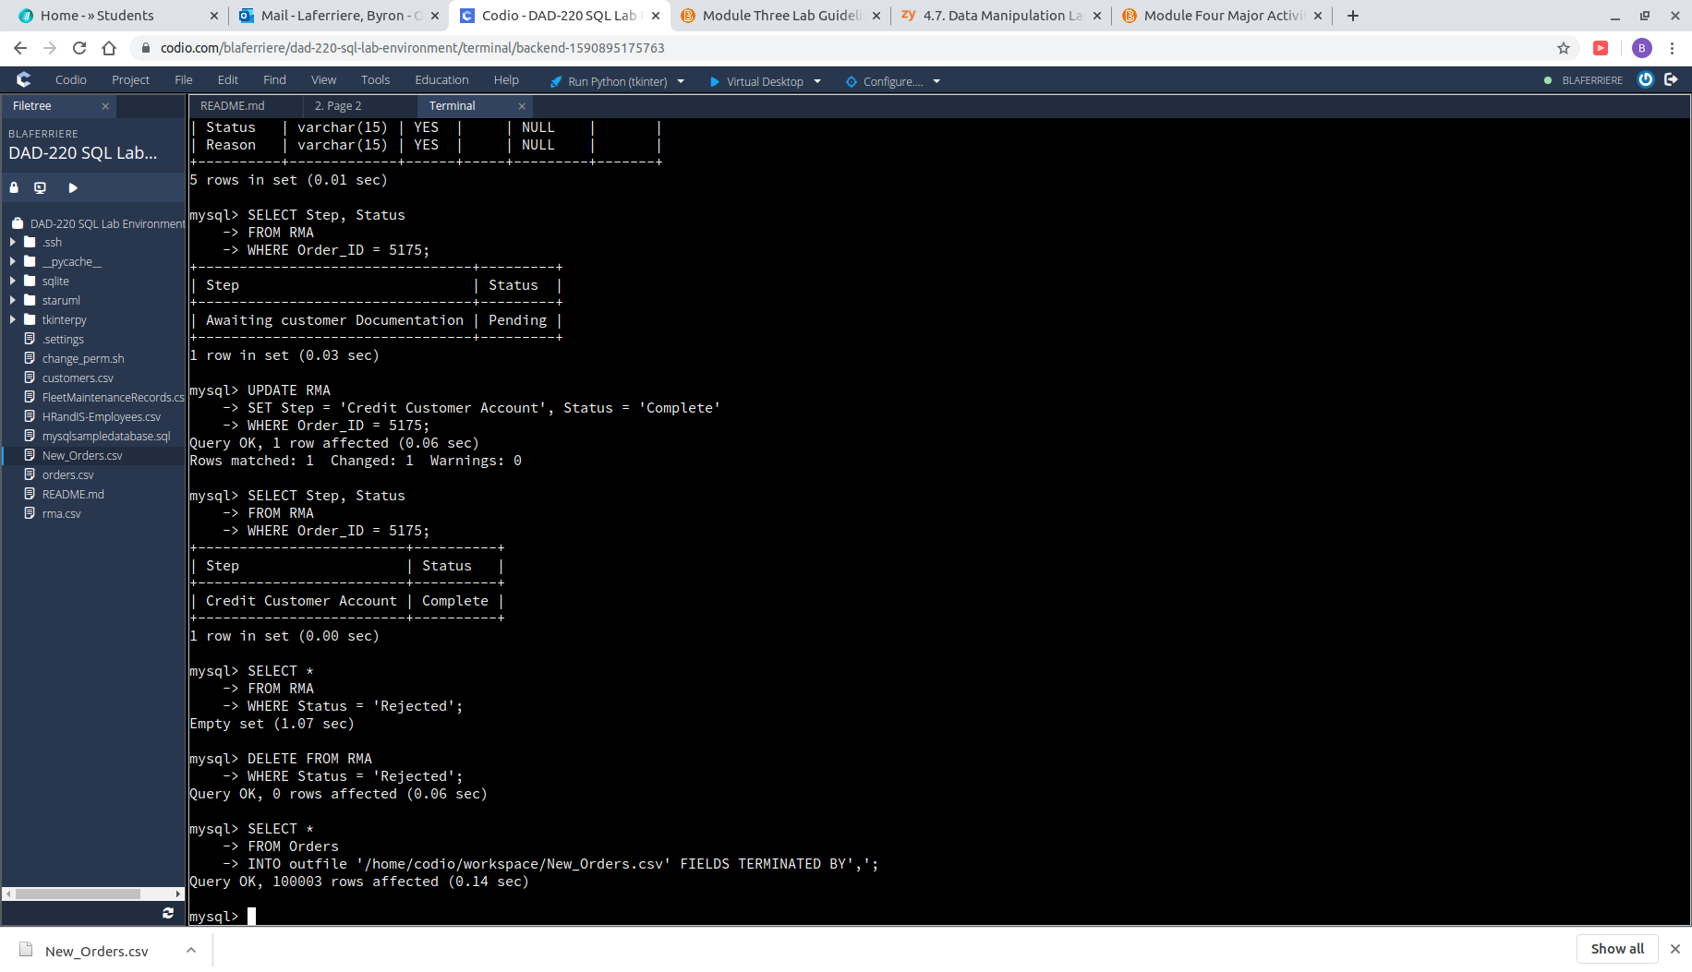
In order to write a file out a .CSV, the SELECT * FROM Orders command combined with the INTO outfile command, allows the user to also choose the name of the path.

